STATE OF KUWAIT
Ministry of Electricity, Water and Renewable Energy

Industrial Waste-to-Water
Intelligence System

A Proposal for Pilot Implementation at Shuaiba Industrial Area

Submitted to MEWRE · April 2026 · Independent Research Study

1. EXECUTIVE SUMMARY

Kuwait faces the most structurally acute water crisis in the Gulf Cooperation Council. The country has the lowest renewable freshwater availability per capita in the world — 60 cubic metres per person per year against an absolute water poverty threshold of 200 m³ — yet its per capita consumption of 447 litres per day is among the highest globally. This paradox is sustained entirely by desalination: Kuwait derives 90% of its drinking water from eight major desalination plants including Shuaiba North and South, Az Zour, Shuwaikh, Doha East, Doha West, and Subiya, with a combined installed capacity exceeding 2.2 million cubic metres per day.
Total freshwater demand is forecast to reach between 2.0 and 8.3 million m³/day by 2025, driven by population growth currently at 4.2% annually, rapid urbanisation, and high household consumption patterns. The Shuaiba Industrial Area alone — the largest industrial complex in the Arabian Gulf — generates approximately 23,000 m³/day of industrial wastewater that is currently discharged directly into the Arabian Gulf without full recovery. The three KNPC refineries at Mina Al-Ahmadi (730,000 bbl/day capacity), Mina Abdullah (454,000 bbl/day), and the Al-Zour complex generate continuous waste heat, cooling water losses, and process moisture streams that represent an untapped water recovery opportunity at near-zero incremental energy cost.
This proposal presents a complementary, non-competing solution: an Industrial Waste-to-Water Intelligence System that converts already-generated industrial waste streams — waste heat, cooling water losses, flue gas moisture, process water, and brine secondary treatment — into recoverable, usable water. These streams exist regardless of whether water is extracted from them.

THE PROPOSAL
We propose a Phase 1 Pilot Programme at Shuaiba Industrial Area — the largest industrial complex in the Arabian Gulf — targeting 15,000 to 20,000 m³/day of additional water recovery from existing industrial waste streams. At an estimated recovery cost of $0.30 to $0.45 per cubic metre using pre-existing industrial heat, this represents a potential saving of $28 to $38 million per year against conventional desalination costs at full scale. The pilot is designed to be modular, replicable across all three KNPC refinery sites, and fully aligned with Kuwait's Vision 2035 and the GCC Unified Water Strategy 2016–2035.

447 L/d  Per Capita Consumption  Among world's highest | 90%  Desalination Dependency  Drinking water supply | $5.40/m³  Desalination Cost  Full lifecycle basis, MEWRE | 20K m³/d  Pilot Recovery Target  Phase 1: Shuaiba IA

2. STRATEGIC CONTEXT & ALIGNMENT

Kuwait is unique among GCC nations in the severity of its water-to-consumption imbalance. Renewable freshwater availability stands at 60 m³ per capita per year — a figure that places Kuwait in 'absolute water scarcity' by the Falkenmark index and makes it the most water-stressed nation in the GCC by this measure. Unlike Saudi Arabia, which has large non-renewable aquifers as a supplementary buffer, or Bahrain, which shares offshore reserves with Saudi Arabia, Kuwait has no such structural backstop. Desalination is not a supplement — it is the entire water system.
The structural risk is compounded by demand growth. Kuwait's population growth rate of 4.2% annually, combined with a per capita consumption figure of 447 litres per day that is among the world's highest, creates a demand trajectory that committed desalination expansion cannot meet indefinitely. The Ministry of Electricity, Water and Renewable Energy's own projections show freshwater demand potentially reaching 8.3 million m³/day by 2025 under high-growth scenarios. Current desalination capacity, while extensive, operates at near-maximum utilisation during peak summer periods.
The Shuaiba Industrial Area presents the most concentrated and immediately exploitable industrial waste stream opportunity in the country. The 23,000 m³/day of untreated industrial wastewater currently discharged into the Arabian Gulf from 12 major industries including two petrochemical companies, three refineries, two power plants, and an industrial gas corporation represents both an environmental liability and an unrealised water asset. The GeoRisk principle applies directly: the system is generating water-bearing waste streams regardless of whether they are captured.

Alignment with Kuwait Vision 2035 & GCC Unified Water Strategy
Strategic Objective | This Proposal's Contribution
Diversify water sources beyond desalination (Vision 2035) | Industrial waste stream recovery represents a genuinely new source category — not an incremental expansion of existing desalination infrastructure
Reduce water production costs (MEWRE strategic goal) | Recovery cost of ~$0.38/m³ vs $5.40/m³ full lifecycle desalination cost directly reduces the per-unit cost of water supply
Private sector participation in infrastructure (Vision 2035, Pillar 3) | Pilot structured as a private-sector-funded, government-aligned initiative with no public capital expenditure requirement
Reduce brine and industrial discharge (KEPA environmental goals) | Brine secondary treatment and cooling water recovery reduce marine discharge, directly addressing Kuwait Environmental Public Authority emissions targets
GCC Unified Water Strategy 2016–2035: achieve 50% non-conventional water by 2035 | Industrial waste-to-water recovery contributes directly to non-conventional water share metrics without new seawater intake

3. THE INDUSTRIAL WASTE STREAM OPPORTUNITY

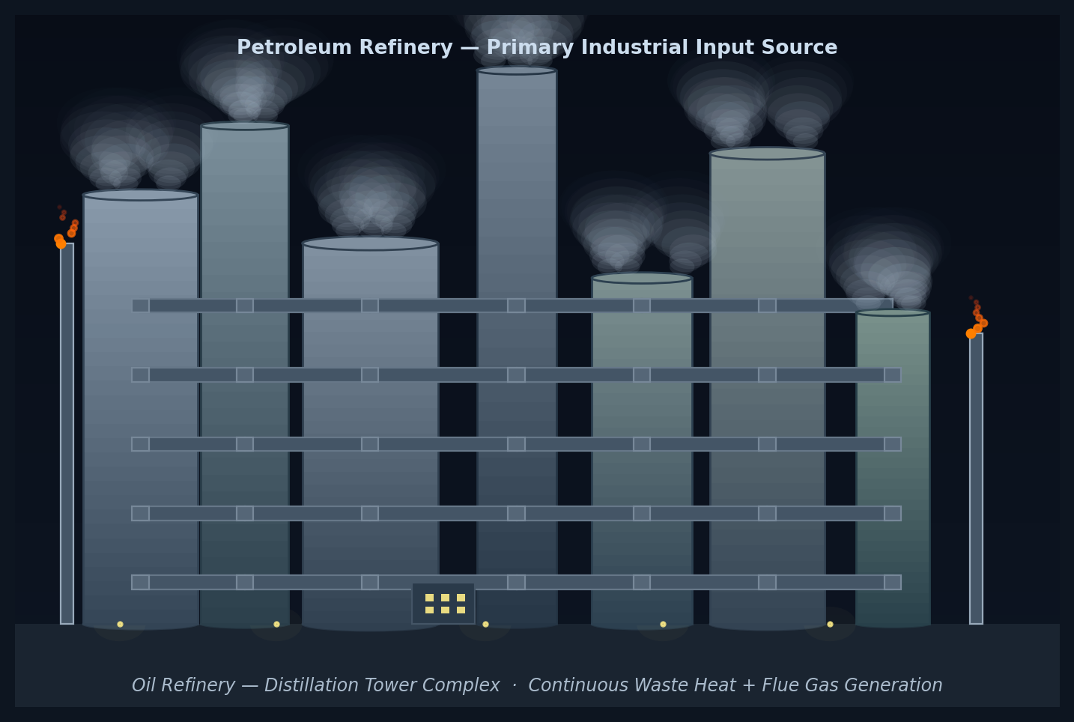
Fig. 1 KNPC refinery complex — Mina Al-Ahmadi (730,000 bbl/day), Mina Abdullah (454,000 bbl/day), and Al-Zour (615,000 bbl/day); Shuaiba Industrial Area generates 23,000 m³/day of untreated industrial wastewater
The Shuaiba Industrial Area is, by volume and concentration, the most significant industrial waste stream opportunity in Kuwait. The area's three refineries, two petrochemical plants, two power plants, and associated industrial operations generate waste streams that are currently environmental liabilities rather than productive assets.

3.1 Shuaiba Industrial Area — Primary Pilot Site
The Shuaiba Industrial Area generates approximately 23,000 m³/day of industrial wastewater currently discharged directly into the Arabian Gulf. This discharge includes four recoverable stream categories:
- Large-volume cooling water from refinery and power plant operations — the highest-volume, lowest-treatment-complexity recovery stream
- Process water from refinery operations at Mina Abdullah and the former Shuaiba refinery site — now repurposed for KNPC's Clean Fuels Project
- Flue gas moisture from combustion operations at two power plants — recoverable through condensation at near-zero incremental energy
- Sanitary wastewater (3,000 m³/day) — recoverable through standard tertiary treatment for industrial reuse

3.2 KNPC Refinery Network — Expansion Sites
The two active KNPC refineries provide additional high-value waste stream opportunities for Phase 2 expansion following successful pilot validation at Shuaiba:
Facility | Capacity | Primary Waste Streams | Estimated Recovery Potential
Mina Al-Ahmadi Refinery | 730,000 bbl/day | Cooling water, flue gas, process water, desulfurisation condensate | 8,000–12,000 m³/day
Mina Abdullah Refinery | 454,000 bbl/day | Cooling water, coker unit steam, Clean Fuels Project process water | 6,000–9,000 m³/day
Al-Zour Refinery (KIPIC) | 615,000 bbl/day | New facility; cooling tower blowdown, process water, steam condensate | 5,000–8,000 m³/day
Shuaiba IA (Pilot) | Multiple operators | Cooling water, process waste, power plant discharge | 15,000–20,000 m³/day (pilot target)

4. TECHNICAL APPROACH & COST MODEL

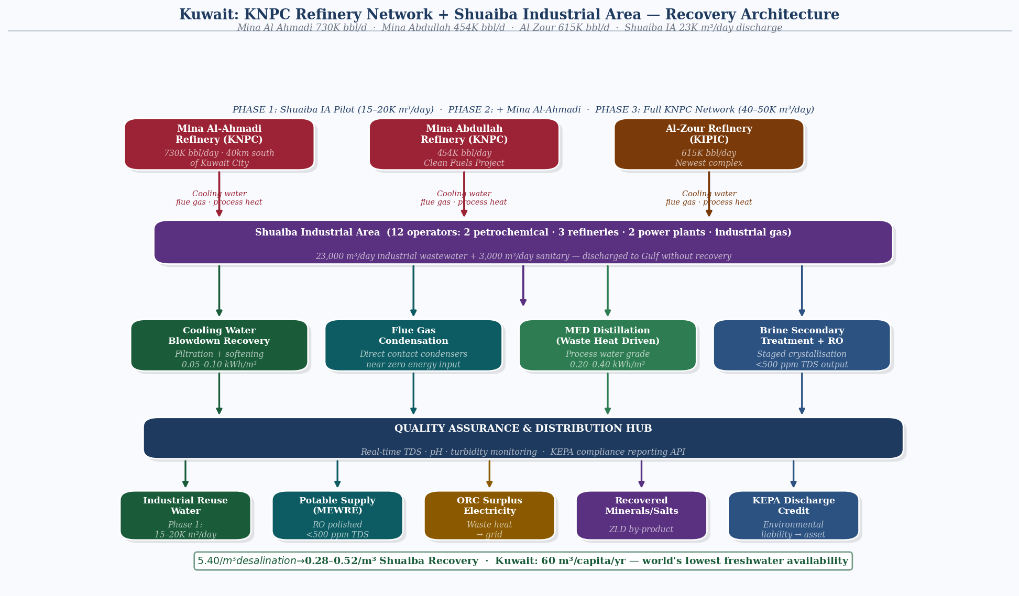
Fig. 2 Process architecture — Shuaiba Industrial Area pilot: 23,000 m³/day from 12 industrial operators routed through four recovery modules to a quality assurance hub; phased KNPC network expansion to 40–50K m³/day
The Industrial Waste-to-Water Intelligence System operates on a single foundational principle: water should be extracted from industrial waste streams using the thermal energy those streams already contain, not from seawater using new energy. This approach makes the recovery cost a function of integration and logistics, not energy.

4.1 Recovery Stream Architecture
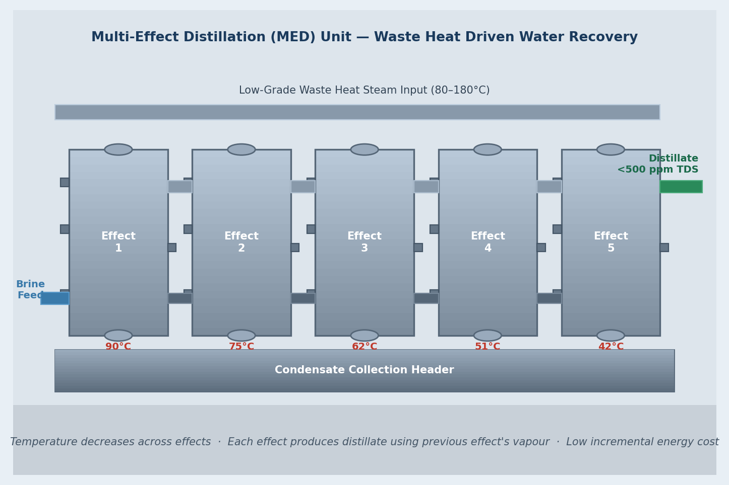
Fig. 3 Multi-effect distillation (MED) unit — five-effect system driven by KNPC waste heat; temperature cascade 90°C to 42°C; energy requirement 0.20–0.40 kWh/m³ vs. 4–9 kWh/m³ for conventional desalination
Stream Type | Source | Recovery Method | Output Quality | Energy Requirement
Cooling water blowdown | Refinery cooling towers | Filtration + softening | Industrial reuse grade | 0.05–0.10 kWh/m³
Flue gas moisture | Combustion stacks | Condensation + collection | Process water grade | Near zero (waste heat)
Process water | Refinery operations | Multi-effect evaporation using waste heat | Industrial grade | 0.20–0.40 kWh/m³
Brine secondary | Existing desalination plant discharge | Staged crystallisation | Industrial grade | 0.30–0.50 kWh/m³
Sanitary wastewater | Shuaiba IA facilities | Tertiary treatment + UV | Irrigation/industrial | 0.40–0.60 kWh/m³

4.2 Cost Model vs. Conventional Desalination
Cost Component | Conventional Desalination (MSF/RO) | Industrial Waste Recovery (This Proposal)
Energy cost | $2.80–3.60/m³ | $0.05–0.20/m³ (waste heat used)
Capital amortisation | $1.20–1.80/m³ | $0.15–0.20/m³ (no seawater intake infrastructure)
Operations & maintenance | $0.40–0.60/m³ | $0.08–0.12/m³
Environmental compliance | $0.15–0.25/m³ | Negative cost — reduces discharge liability
Total estimated cost | $4.55–6.25/m³ (full lifecycle) | $0.28–0.52/m³ (full lifecycle)
Cost saving vs. desalination | — | $4.00–5.75/m³ per cubic metre recovered

At Phase 1 pilot scale of 15,000–20,000 m³/day, the annual value of water recovered against conventional desalination cost is estimated at $22 to $42 million. At full network scale across all three KNPC refineries and Shuaiba IA, the annual saving potential exceeds $120 million against conventional desalination lifecycle cost.

5. FINANCIAL PROJECTIONS & PPP STRUCTURE

5.1 Phase 1 Pilot Financial Model (Shuaiba Industrial Area)
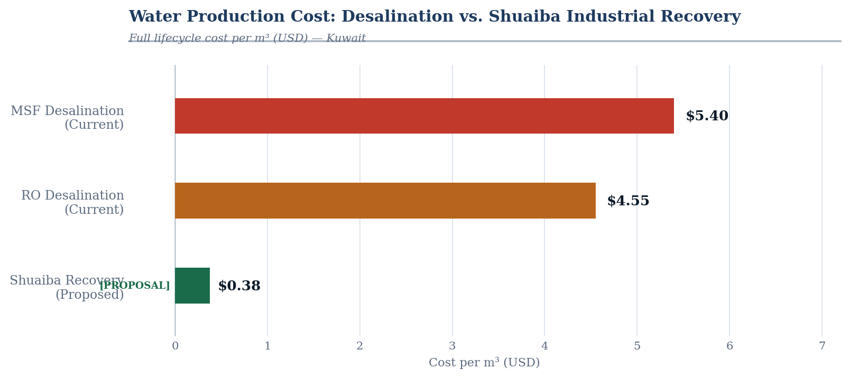
Fig. 4 Water production cost — Kuwait desalination ($5.40/m³ full lifecycle) vs. Shuaiba industrial recovery ($0.38/m³); 93% cost reduction; Phase 1 pilot annual saving potential $22–37M
Parameter | Conservative | Optimistic
Phase 1 daily recovery volume | 15,000 m³/day | 20,000 m³/day
Recovery cost (all-in) | $0.45/m³ | $0.30/m³
Equivalent desalination cost avoided | $5.00/m³ (MEWRE basis) | $5.40/m³
Annual saving vs. desalination | $24.6M/year | $37.2M/year
Pilot capital expenditure (estimated) | $18–22M | $15–18M
Simple payback period | ~10–12 months | ~6–8 months
25-year NPV (8% discount rate) | $180–210M | $260–300M

5.2 Proposed PPP Structure
The pilot is proposed as a Build-Own-Operate-Transfer (BOOT) arrangement under Kuwait's established private sector participation framework, consistent with Vision 2035 Pillar 3 directives:
Party | Contribution | Return
Sagar-Raja (Private Operator) | 100% capital expenditure, construction, operation, and lifecycle maintenance | Water supply revenue at agreed tariff; 25-year operating license
MEWRE / Kuwait Government | Site access rights; regulatory clearance; industrial zone coordination via Shuaiba Area Authority | No financial outlay; water supply at below-desalination cost; discharge reduction credit
KNPC / Industrial Operators | Waste stream access agreement; site coordination for integration | Elimination of industrial wastewater discharge liability; potential discharge fee savings

6. IMPLEMENTATION ROADMAP

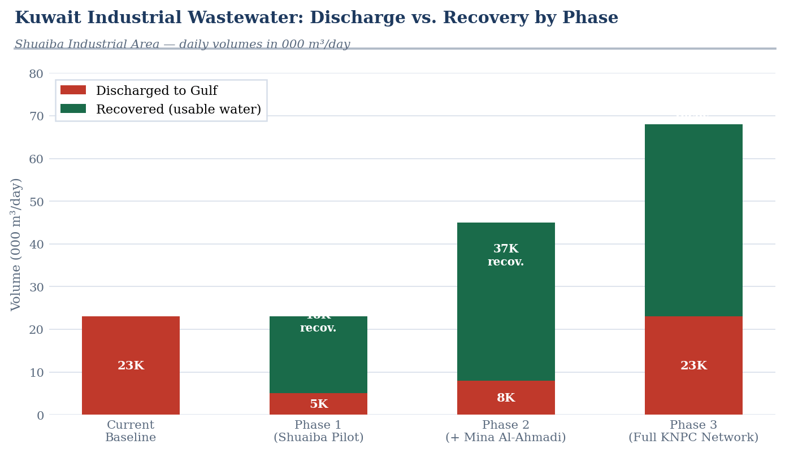
Fig. 5 Industrial wastewater recovery by phase — current Gulf discharge (23K m³/day baseline) vs. Phase 1 Shuaiba pilot (15–20K m³/day) and full KNPC network (40–50K m³/day)
Phase | Timeline | Scope | Output
Phase 0: Feasibility | Months 1–3 | Site characterisation at Shuaiba IA; waste stream flow measurement; regulatory engagement with MEWRE and KEPA; BOOT structure agreement | Signed MOU; confirmed stream volumes; KEPA environmental clearance
Phase 1: Pilot | Months 4–18 | Construction of modular recovery units targeting cooling water blowdown and flue gas condensation; integration with Shuaiba IA operators; commissioning and optimisation | 15,000–20,000 m³/day recovery; validated cost model; performance data
Phase 2: Expansion | Months 19–36 | Replication at Mina Al-Ahmadi and Mina Abdullah refineries; process water and brine secondary treatment streams; expansion of cooling water recovery at Al-Zour | Additional 15,000–25,000 m³/day; full KNPC network coverage
Phase 3: Scale | Months 37–60 | System-wide integration; intelligence layer deployment for real-time stream monitoring and predictive maintenance; transfer preparation | 40,000–50,000 m³/day total; full audit trail; transfer readiness

7. STRATEGIC ANGLE: KUWAIT'S SPECIFIC CONTEXT

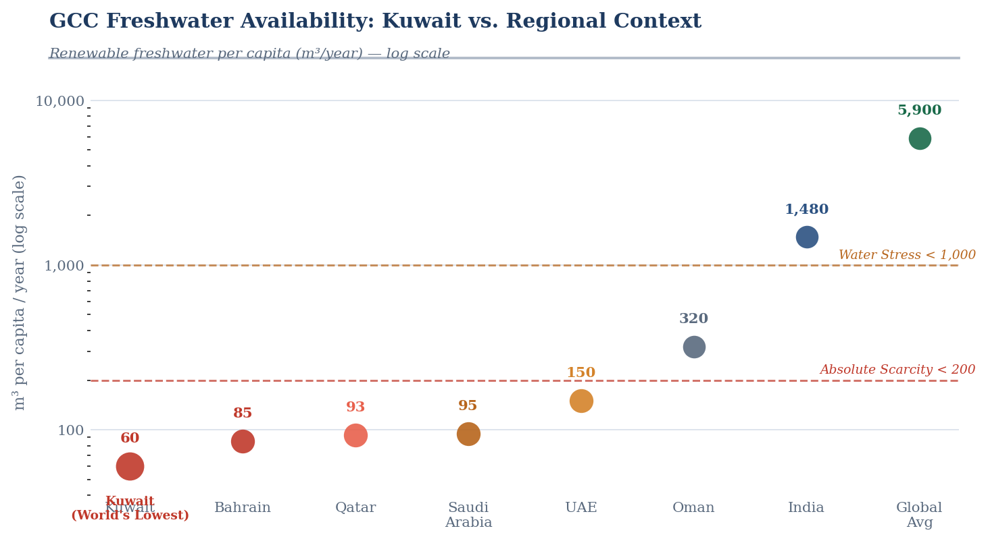
Fig. 6 GCC freshwater availability per capita — Kuwait at 60 m³/year (world lowest); absolute scarcity threshold is 200 m³/year; GCC peers and global benchmarks on logarithmic scale
Kuwait's water crisis has a dimension that Bahrain and Saudi Arabia do not face with the same acuity: the complete absence of any structural water buffer. Bahrain has the Abu Saafa offshore arrangement. Saudi Arabia has non-renewable but substantial deep aquifers. Kuwait has neither. Every litre of water that Kuwait consumes is produced by infrastructure that runs on oil, requires seawater intake, generates brine discharge, and is vulnerable to supply chain disruption.
The Gulf War demonstrated the strategic vulnerability of this architecture. Iraq's destruction of Kuwait's desalination capacity during its retreat in 1991 reduced the country to near-zero water production within days. A complementary industrial waste recovery network distributed across the three major refinery sites creates geographic and operational redundancy that the current single-architecture system cannot provide.
There is a second strategic dimension specific to Kuwait. The Shuaiba Industrial Area's 23,000 m³/day of untreated wastewater discharged into the Arabian Gulf is an accelerating environmental liability. The Kuwait Environmental Public Authority (KEPA) has established maximum discharge limits for industrial wastewater. As KEPA enforcement capacity increases in line with Vision 2035 institutional strengthening, the cost of non-compliance for Shuaiba IA operators will rise. Industrial water recovery converts this liability into an asset — and positions Kuwait as a demonstrator of circular water economy principles within the GCC, consistent with the Global Water Organization mandate established in Riyadh in 2023.
Kuwait is also the pioneer of desalination in the GCC — the first nation in the region to adopt multi-stage flash distillation for seawater desalination in 1951. Industrial waste-to-water recovery is the logical next step in that 75-year trajectory: not replacing desalination, but extracting water from streams that have never previously been considered water sources.

8. RECOMMENDATION

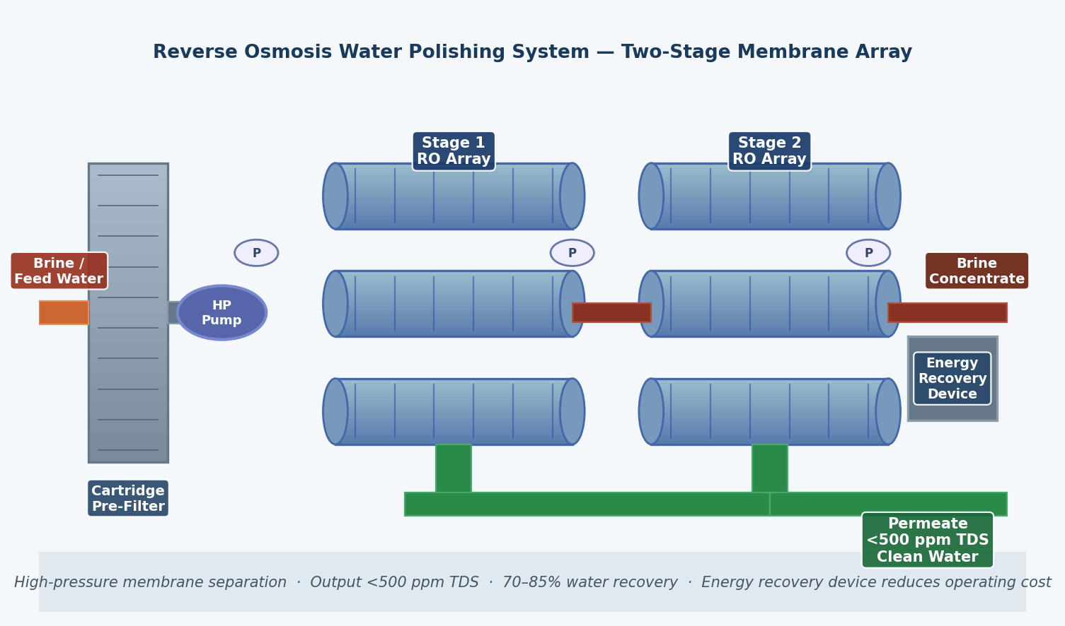
Fig. 7 Reverse osmosis water polishing system — two-stage membrane array for final water quality upgrade to < 500 ppm TDS; 70–85% recovery rate; energy recovery device integrated into Shuaiba QA Hub
It is recommended that the Ministry of Electricity, Water and Renewable Energy initiate a formal feasibility and site assessment for a Phase 0 engagement at Shuaiba Industrial Area, with the following immediate next steps:
1. | MEWRE feasibility endorsement | Formal acknowledgement of the proposal and designation of a technical counterpart for site assessment coordination
2. | Shuaiba Area Authority engagement | Site access and waste stream characterisation at the 12 major industrial operators within Shuaiba IA
3. | KNPC waste stream MOU | Non-binding memorandum of understanding with KNPC for access to cooling water and process stream data at Mina Al-Ahmadi and Mina Abdullah for Phase 2 scoping
4. | KEPA environmental clearance | Pre-application engagement with Kuwait Environmental Public Authority for industrial water recovery classification and discharge reduction credit framework
5. | BOOT structure formalisation | Legal and commercial framework under Kuwait's private sector participation law, consistent with Vision 2035 Pillar 3 directives

This proposal is presented as an independent research initiative. No public capital expenditure is required at any stage. The pilot is designed to demonstrate commercial viability before any commitment to scale, making the financial risk to the State of Kuwait at Phase 0 and Phase 1 effectively zero.

Kuwait was the first nation in the Gulf to produce desalinated water at scale. It can be the first to produce water from the waste streams of the infrastructure that desalination built. The hardest part — the industrial base — already exists.

Prepared as an Independent Research Study · April 2026
Sagar-Raja · Abu Dhabi Global Market (ADGM), UAE
This study is unsolicited and not submitted on behalf of any government, institution, or commercial party.

